Kevin Chung

1/13/20-1/17/20

Period 5

Journal 15

I made lots of progress this week. I trained my neural network with a new set of data, since my old dataset had mislabeled images. The method I used to collect the new data was more efficient than my previous method and more accurate. After ~600 epochs of training, my model had 94.7% accuracy on the training set and 94.1% accuracy on the validation set. This accuracy is good enough to detect a board in an image at most angles, but it starts to become faulty when the angle of the image becomes lower and lower.

The image on the left shows which intersections the CNN believes are valid lattice points. It is mostly correct, but there is one false positive in the top left corner. Additionally, there are lattice points that are not detected because they are being occluded by a piece. The method I used to find the lines on the right image was the method used in Czyzewski, et al. It utilizes a polyscore function that is higher the better the chessboard is. The algorithm runs through every combination of vertical and horizontal lines and takes the lines that give the highest polyscore.

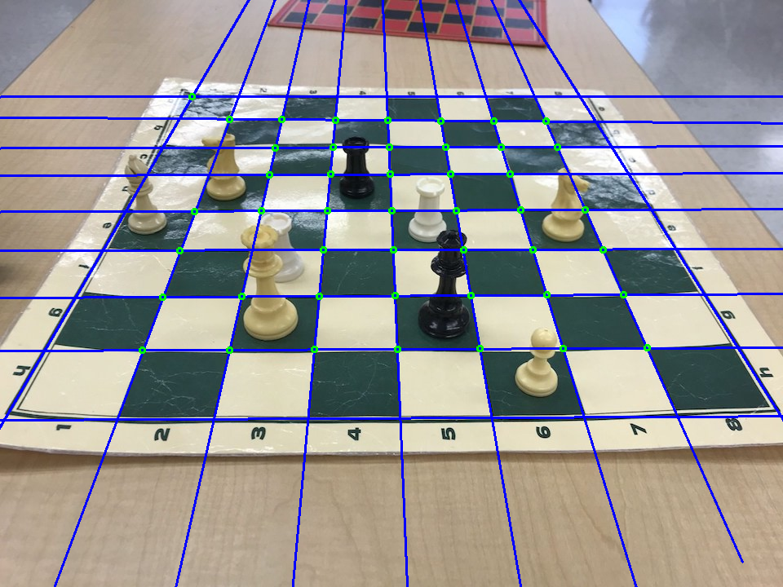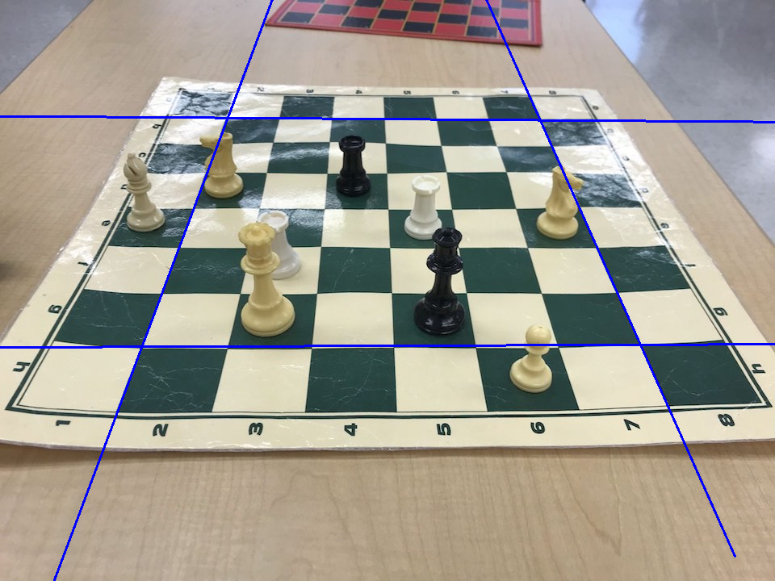

These images show the same data as before but with a lower angle. There are more stray lines in this image, causing more false positives. These false positives confuse the board detection algorithm, making it believe that the diagonal line is the top of the board. I believe that this can be improved with more training on a wider range of images for the CNN.

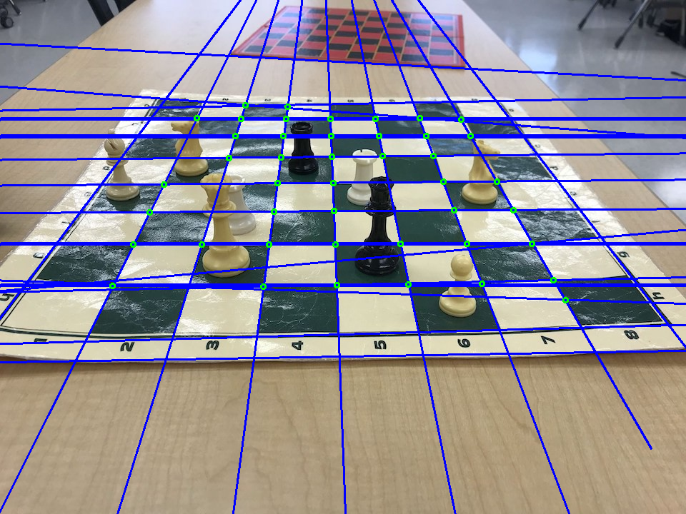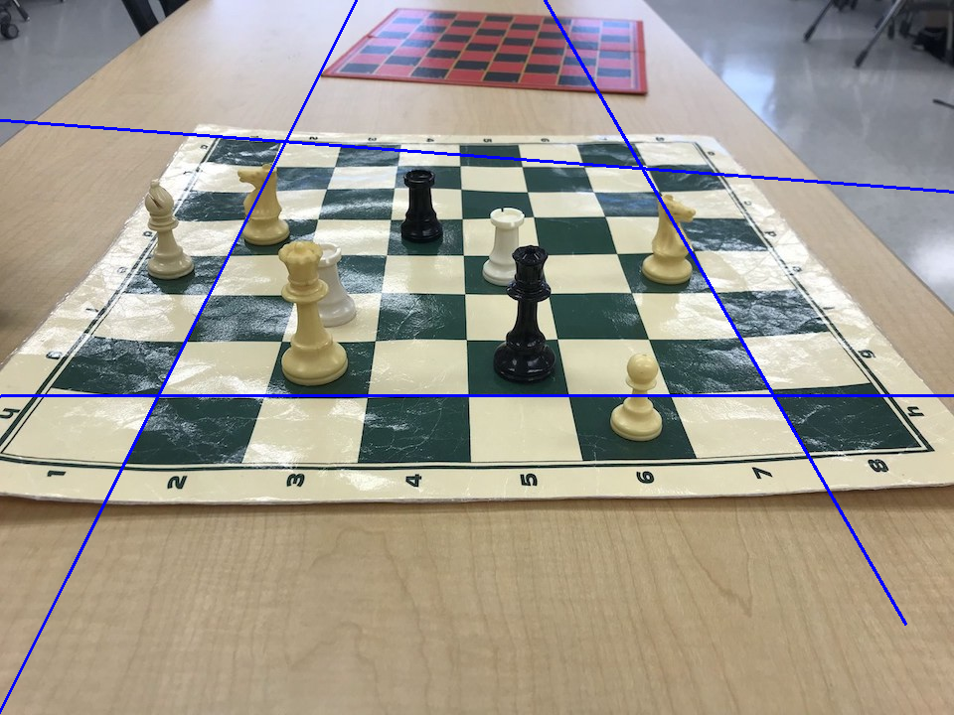

My partner and I also met up with Dr. White and Dr. Gabor to discuss our current progress and plans for the next month. Our agenda is currently to set up a demo that can easily be shown by just one person. This is easily accomplished by writing a shell that combines both of our modules and runs it on a live camera feed. Additionally, I will look at ways to increase the range of acceptable camera angles for board detection and also figure out how to detect when a move has been made.